Component List:

1x Arduino uno
1x Breadboard
1x Servo similar to the below
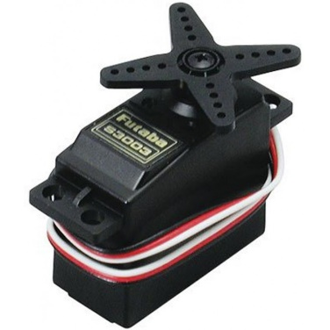
Hand full of jumper wires (M-M)
Header pins
2x 10k resistors
2x 20k resistors
Battery bank (for Arduino and raspberry pi if possible)

